Bahria University,

Karachi Campus



COURSE: SEN-310 WEB ENGINEERING

TERM: SPRING 2022, CLASS: BSE- 6 (B)

Assignment 1

Submitted By:

MUHAMMAD SOHAIL ABBAS 02-131192-012 65128

(Name) (Reg. No.)

Submitted To:

ENGR. Syed Ahmed Hassan Bukhari

Submitted On:

02/04/2022

Signed Remarks: Score: Pakistan

**Task 1:** Using the knowledge gained by learning and implementing HTML5, CSS and Flexbox. Design a single page website which should be based on your own interests and hobbies. The color themes and good concepts should be visible on your website. Submission must include the following:

1. Html5 Script
2. CSS Script
3. Screenshot of your website

**Solution:**

**Code:**

* **HTML:**

<!DOCTYPE html>

<html lang="en">

<head>

<meta charset="UTF-8" />

<meta http-equiv="X-UA-Compatible" content="IE=edge" />

<meta name="viewport" content="width=device-width, initial-scale=1.0" />

<link rel="stylesheet" href="assets/style.css" />

<link

rel="stylesheet"

href="https://cdnjs.cloudflare.com/ajax/libs/font-awesome/4.7.0/css/font-awesome.min.css"

/>

<link rel="icon" href="assets/img/logo.png" type="image/x-icon" />

<script src="https://kit.fontawesome.com/a076d05399.js"></script>

<title>Beat</title>

</head>

<body>

<!-- Navbar Starts -->

<nav>

<ul>

<li><img src="assets/img/logo.png" /></li>

<li><a href="#home">Home</a></li>

<li><a href="#about">About</a></li>

<li><a href="#music">Music</a></li>

<li><a href="#membership">Membership</a></li>

<li><a href="#ad-video">Ad-Video</a></li>

<li><a href="#contact">Contact</a></li>

</ul>

</nav>

<!-- Navbar Ends -->

<!-- Home Page start -->

<section class="home" id="home">

<div class="container">

<div class="home-img">

<img src="assets/img/home.png" alt="" />

</div>

<div class="home-text">

<h1>Welcome to BEAT...</h1>

<p>

Lorem ipsum dolor sit amet consectetur adipisicing elit. Maiores,

impedit. <br />Iure dignissimos architecto tempora sunt saepe beatae

quam ipsa obcaecati impedit,<br />

unde aut, atque veritatis doloribus nostrum consequuntur! Nisi,

sunt?

</p>

</div>

</div>

</section>

<!-- Home page ends -->

<!-- About page start -->

<section class="about" id="about">

<div class="about-container">

<div class="about-text">

<h1>About Us</h1>

<p>

Lorem ipsum dolor sit amet consectetur adipisicing elit. Maiores,

impedit. <br />Iure dignissimos architecto tempora sunt saepe beatae

quam ipsa obcaecati impedit,<br />

unde aut, atque veritatis doloribus nostrum consequuntur! Nisi,

sunt?

</p>

</div>

<div class="about-img">

<img src="assets/img/about.png" alt="" />

</div>

</div>

</section>

<!-- Music -->

<section class="music" id="music">

<div class="music-containers">

<h1>Our Collections</h1>

<div class="music_cards">

<a href="#" class="btn"><i class="fa fa-play"> Song 1</i></a>

<a href="#" class="btn"><i class="fa fa-play"> Song 1</i></a>

<a href="#" class="btn"><i class="fa fa-play"> Song 1</i></a>

<a href="#" class="btn"><i class="fa fa-play"> Song 1</i></a>

<a href="#" class="btn"><i class="fa fa-play"> Song 1</i></a>

<a href="#" class="btn"><i class="fa fa-play"> Song 1</i></a>

</div>

<div class="music_cards">

<a href="#" class="btn"><i class="fa fa-play"> Song 1</i></a>

<a href="#" class="btn"><i class="fa fa-play"> Song 1</i></a>

<a href="#" class="btn"><i class="fa fa-play"> Song 1</i></a>

<a href="#" class="btn"><i class="fa fa-play"> Song 1</i></a>

<a href="#" class="btn"><i class="fa fa-play"> Song 1</i></a>

<a href="#" class="btn"><i class="fa fa-play"> Song 1</i></a>

</div>

<div class="music_cards">

<a href="#" class="btn"><i class="fa fa-play"> Song 1</i></a>

<a href="#" class="btn"><i class="fa fa-play"> Song 1</i></a>

<a href="#" class="btn"><i class="fa fa-play"> Song 1</i></a>

<a href="#" class="btn"><i class="fa fa-play"> Song 1</i></a>

<a href="#" class="btn"><i class="fa fa-play"> Song 1</i></a>

<a href="#" class="btn"><i class="fa fa-play"> Song 1</i></a>

</div>

<div class="music_cards">

<a href="#" class="btn"><i class="fa fa-play"> Song 1</i></a>

<a href="#" class="btn"><i class="fa fa-play"> Song 1</i></a>

<a href="#" class="btn"><i class="fa fa-play"> Song 1</i></a>

<a href="#" class="btn"><i class="fa fa-play"> Song 1</i></a>

<a href="#" class="btn"><i class="fa fa-play"> Song 1</i></a>

<a href="#" class="btn"><i class="fa fa-play"> Song 1</i></a>

</div>

<div class="music_cards">

<a href="#" class="btn"><i class="fa fa-play"> Song 1</i></a>

<a href="#" class="btn"><i class="fa fa-play"> Song 1</i></a>

<a href="#" class="btn"><i class="fa fa-play"> Song 1</i></a>

<a href="#" class="btn"><i class="fa fa-play"> Song 1</i></a>

<a href="#" class="btn"><i class="fa fa-play"> Song 1</i></a>

<a href="#" class="btn"><i class="fa fa-play"> Song 1</i></a>

</div>

</div>

</section>

<!-- Music ends -->

<!-- Membership -->

<section class="membership" id="membership">

<div class="membership-container">

<div class="wrapper">

<div class="table basic">

<div class="head_tab">

<h2>

Mini<br />

One-time plan

</h2>

</div>

<div class="aj_p"><p>1 account</p></div>

<div class="price-section">

<div class="price-area">

<div class="inner-area">

<span class="text">$</span>

<span class="price"

>1.00<span style="font-size: 12px">/day</span></span

>

</div>

</div>

</div>

<div class="package-name"></div>

<ul class="features">

<div class="btn"><button>Get Started</button></div>

<p class="aj_des">$0.8/day when you renew</p>

<li>

<span class="list-name">Ad-free music listening on mobile</span>

<span class="icon check"><i class="fas fa-check"></i></span>

</li>

<li>

<span class="list-name"

>Download 30 Songs on one mobile Device</span

>

<span class="icon check"><i class="fas fa-check"></i></span>

</li>

<li>

<span class="list-name">Create Your own PLaylist</span>

<span class="icon check"><i class="fas fa-check"></i></span>

</li>

</ul>

<div>

<h2>

See all features

<span class="icon cross"><i class="fa fa-angle-down"></i></span>

</h2>

</div>

</div>

<div class="table premium">

<div class="head_tab">

<h2>Duo <br />1 month Subscription</h2>

</div>

<div class="aj_p"><p>2 accounts</p></div>

<!-- <div class="ribbon"><span>BEST VALUE</span></div> -->

<div class="price-section">

<div class="price-area">

<div class="inner-area">

<span class="text">$</span>

<span class="price"

>5<span style="font-size: 12px">/mo</span></span

>

</div>

</div>

</div>

<div class="package-name"></div>

<ul class="features">

<div class="btn"><button>Get Started</button></div>

<p class="aj_des">$4.8/mo when you renew</p>

<li>

<span class="list-name">Ad-free music listening on mobile</span>

<span class="icon check"><i class="fas fa-check"></i></span>

</li>

<li>

<span class="list-name"

>2 premium accounts for couple under one roof

</span>

<span class="icon check"><i class="fas fa-check"></i></span>

</li>

<li>

<span class="list-name"

>Play offline and create own playlist</span

>

<span class="icon check"><i class="fas fa-check"></i></span>

</li>

</ul>

<div class="premium_all">

<h2>

See all features

<span class="icon cross"><i class="fa fa-angle-down"></i></span>

</h2>

</div>

</div>

<div class="table ultimate">

<div class="head_tab">

<h2>Family <br />1 month Subscription</h2>

</div>

<div class="aj_p"><p>Up to 6 accounts</p></div>

<div class="price-section">

<div class="price-area">

<div class="inner-area">

<span class="text">$</span>

<span class="price"

>7<span style="font-size: 12px">/mo</span></span>

</div>

</div>

</div>

<div class="package-name"></div>

<ul class="features">

<div class="btn"><button>Get Started</button></div>

<p class="aj_des">$6.8/mo when you renew</p>

<li>

<span class="list-name"

>6 premium accounts for family living under one roof</span

>

<span class="icon check"><i class="fas fa-check"></i></span>

</li>

<li>

<span class="list-name"

>Block Explicit Music and Parental control

</span>

<span class="icon check"><i class="fas fa-check"></i></span>

</li>

<li>

<span class="list-name">Ad-free music listening on mobile</span>

<span class="icon check"><i class="fas fa-check"></i></span>

</li>

</ul>

<div>

<h2>

See all features

<span class="icon cross"><i class="fa fa-angle-down"></i></span>

</h2>

</div>

</div>

</div>

</div>

</section>

<!-- Membership end -->

<section class="ad-video" id="ad-video">

<div class="laptop-container" id="laptop">

<div class="mockup mockup-macbook loaded opened">

<div class="part top">

<img

src="https://d1xm195wioio0k.cloudfront.net/images/mockup/macbook-top.svg"

alt=""

class="top"

/>

<img

src="https://d1xm195wioio0k.cloudfront.net/images/mockup/macbook-cover.svg"

alt=""

class="cover"

/>

<video autoplay playsinline autoplay muted loop>

<source src="assets/img/tourVideo.mp4" type="video/mp4" />

</video>

</div>

<div class="part bottom">

<img

src="https://d1xm195wioio0k.cloudfront.net/images/mockup/macbook-cover.svg"

alt=""

class="cover"

/>

<img

src="https://d1xm195wioio0k.cloudfront.net/images/mockup/macbook-bottom.svg"

alt=""

class="bottom"

/>

</div>

</div>

<a href="" class="uparrow"><img src="images/up-arrow.png" alt="" /></a>

</div>

</section>

<!-- Contact US -->

<section class="contact" id="contact">

<div class="container-contact">

<div class="content-contact">

<div class="left-side">

<div class="address details">

<i class="fas fa-map-marker-alt"></i>

<div class="topic" style="color: white; font-weight: bold">

Address

</div>

<div class="text-one">Karachi</div>

<div class="text-two">Pakistan</div>

</div>

<div class="phone details">

<i class="fas fa-phone-alt"></i>

<div class="topic" style="color: white; font-weight: bold">

Phone

</div>

<div class="text-one">021 333 333 333</div>

</div>

<div class="email details">

<i class="fas fa-envelope"></i>

<div class="topic" style="color: white; font-weight: bold">

Email

</div>

<div class="text-one">email@gmail.com</div>

<div class="text-two">info.email@gmail.com</div>

</div>

</div>

<div class="right-side">

<div class="topic-text">Send us a message</div>

<p style="color: white">

If you have any work from me or any types of quries related to my

tutorial, you can send me message from here. It's my pleasure to

help you.

</p>

<form action="#">

<div class="input-box">

<input type="text" placeholder="Enter your name" />

</div>

<div class="input-box">

<input type="text" placeholder="Enter your email" />

</div>

<div class="input-box message-box"></div>

<div class="button">

<input type="button" value="Send Now" />

</div>

</form>

</div>

</div>

</div>

</section>

</body>

</html>

* **CSS:**

/* html {

scroll-behavior: smooth;

} */

* {

margin: 0;

padding: 0;

}

body {

background-color: hsl(206, 4%, 6%);

}

nav{

position: fixed; /* Set the navbar to fixed position */

top: 0;

}

nav li {

display: inline-block;

padding-left: 20px;

}

nav li a {

color: #544d4d;

text-decoration: none;

font-size: 20px;

font-family: "Open Sans", sans-serif;

padding-left: 10px;

}

nav li a:hover {

color: whitesmoke;

text-decoration: none;

font-style: italic;

text-decoration: overline;

font-size: 20px;

font-family: "Open Sans", sans-serif;

padding-left: 10px;

}

nav li img {

padding-right: 450px;

padding-left: 30px;

padding-top: 10px;

width: 50px;

height: 50px;

animation: movedown 1s linear 1;

animation-delay: 1s;

overflow: hidden;

visibility: hidden;

animation-fill-mode: forwards;

}

@keyframes movedown {

0% {

transform: translateY(-100px);

visibility: visible;

}

100% {

transform: translateY(10px);

visibility: visible;

}

}

.container {

width: 100%;

height: 100vh;

display: flex;

justify-content: center;

align-items: center;

}

.container .home-img img {

width: 100%;

height: 550px;

animation: moveup 1s linear 1;

animation-delay: 1s;

overflow: hidden;

padding-bottom: 200px;

visibility: hidden;

animation-fill-mode: forwards;

}

@keyframes moveup {

0% {

transform: translateY(100px);

visibility: visible;

}

100% {

transform: translateY(0px);

visibility: visible;

}

}

.container .home-text{

width: 50%;

display: flex;

justify-content: left;

align-items: center;

flex-direction: column;

padding-top: 80px;

animation: moveright 1s linear 1;

animation-delay: 1s;

visibility: hidden;

animation-fill-mode: forwards;

}

@keyframes moveright {

0% {

transform: translateX(-70px);

visibility: visible;

}

100% {

transform: translateX(10px);

visibility: visible;

}

}

.container .home-text h1{

color: white;

margin-top: -200px;

font-size: 70px;

font-family: "Open Sans", sans-serif;

font-style: italic;

}

.container .home-text p{

color: white;

font-size: 20px;

font-family: "Open Sans", sans-serif;

font-style: italic;

}

.container .home-text h1:hover{

color: whitesmoke;

text-decoration: none;

font-style: italic;

font-size: 70px;

font-family: "Open Sans", sans-serif;

padding-left: 15px;

text-shadow: 1px 1px white;

}

/* About */

.about-container{

width: 100%;

height: 100vh;

display: flex;

justify-content: center;

align-items: center;

}

.about-container .about-img img{

width: 100%;

animation: moveup 1s linear 1;

animation-delay: 1s;

overflow: hidden;

padding-bottom: 50px;

visibility: hidden;

animation-fill-mode: forwards;

}

@keyframes moveup {

0% {

transform: translateY(100px);

visibility: visible;

}

100% {

transform: translateY(40px);

visibility: visible;

}

}

.about-container .about-text{

width: 50%;

display: flex;

justify-content: left;

align-items: center;

flex-direction: column;

padding-top: 80px;

animation: moveright 1s linear 1;

animation-delay: 1s;

visibility: hidden;

animation-fill-mode: forwards;

}

.about-container .about-text h1{

color: white;

margin-top: -200px;

font-size: 50px;

font-family: "Open Sans", sans-serif;

font-style: italic;

}

.about-container .about-text p{

color: white;

font-size: 18px;

font-family: "Open Sans", sans-serif;

font-style: italic;

}

.about-container .about-text .sponsore .sponsore-img img{

width: 150px;

height: 100px;

padding-left: 20px;

display: flex inline-block;

justify-content: center;

padding-top: 500px;

}

/* Music Cards */

.music-containers{

width: 100%;

height: 100vh;

display: flex;

justify-content: center;

align-items: center;

}

.music-containers h1{

color: white;

margin-top: 90px;

text-align: center;

font-size: 50px;

font-family: "Open Sans", sans-serif;

font-style: italic;

display: flex;

justify-content: center;

align-items: center;

animation: down 1s linear 1;

animation-delay: 1s;

visibility: hidden;

animation-fill-mode: forwards;

}

@keyframes down {

0% {

transform: translateY(100px);

visibility: visible;

}

100% {

transform: translateY(0px);

visibility: visible;

}

}

.music-containers .music_cards{

width: 100%;

height: 100vh;

display: flex;

color: white;

justify-content: center;

align-items: center;

flex-direction: column;

padding-top: 80px;

/* animation: moveright 1s linear 1;

animation-delay: 1s;

visibility: hidden;

animation-fill-mode: forwards; */

}

.music-containers .music_cards .btn{

display: inline-block;

/* background: linear-gradient(45deg, #87adfe, #ff77cd); */

/* background: linear-gradient(90deg, rgba(0,0,0,1) 0%, rgba(128,128,128,1) 35%, rgba(255,255,255,1) 100%); */

background: radial-gradient(circle, rgba(0,0,0,1) 0%, rgba(128,128,128,1) 35%, rgba(0,0,0,1) 100%);

border-radius: 6px;

padding: 10px 40px;

display: flex;

flex-direction: column;

justify-content: center;

align-items: center;

margin-top: 10px;

box-sizing: border-box;

color: #fff;

text-decoration: none;

box-shadow: 1px 1px 1px #a6a6a6;

animation: moveright 1s linear 1;

animation-delay: 1s;

visibility: hidden;

animation-fill-mode: forwards;

}

.music-containers .music_cards .btn:hover{

display: inline-block;

background: linear-gradient(90deg, rgba(0,0,0,1) 0%, rgba(128,128,128,1) 35%, rgba(255,255,255,1) 100%);

/* background: radial-gradient(circle, rgba(0,0,0,1) 0%, rgba(128,128,128,1) 35%, rgba(0,0,0,1) 100%); */

border-radius: 6px;

padding: 10px 40px;

display: flex;

flex-direction: column;

justify-content: center;

align-items: center;

margin-top: 10px;

box-sizing: border-box;

color: #fff;

text-decoration: none;

box-shadow: 3px 8px 22px #a6a6a6;

}

.music-containers .music_cards .btn .fa:hover{

color: black;

}

/* Membership */

.membership-container{

width: 100%;

height: 100vh;

display: flex;

justify-content: center;

align-items: center;

}

.wrapper{

width: 90%;

margin: 30px;

display: flex;

flex-wrap: wrap;

justify-content:center;

margin-left: 20px;

}

.wrapper .table{

background: linear-gradient(90deg, #bfbfbf 0%, rgba(128,128,128,1) 35%, rgba(255,255,255,1) 100%);

width: calc(30% - 20px);

padding: 10px 20px 20px 20px;

/* position: relative; */

box-shadow: 0 5px 10px rgba(0,0,0,0.1);

text-align: center;

}

.table .price-section{

display: flex;

justify-content: center;

}

.table .price-area{

height: 120px;

width: 120px;

border-radius: 50%;

padding: 2px;

}

.aj_p{

text-align: center;

}

p.aj_des {

color: grey;

padding-bottom: 30px;

font-size: 14px;

}

.table.premium {

margin: -10px;

}

.premium_all {

padding-top: 22px;

}

.price-area .inner-area{

height: 100%;

width: 100%;

line-height: 117px;

text-align: center;

color: #fff;

position: relative;

}

.price-area .inner-area .text{

font-size: 25px;

font-weight: 400;

position: absolute;

top: -10px;

left: 5px;

}

.price-area .inner-area .price{

font-size: 45px;

font-weight: 500;

margin-left: 16px;

}

.table .package-name{

width: 100%;

height: 2px;

margin :35px 0;

position: relative;

}

.table .features li{

margin-bottom: 15px;

list-style: none;

display: flex;

justify-content: space-between;

}

.features li .list-name{

font-size: 17px;

font-weight: 400;

}

.features li .icon{

font-size: 15px;

}

.features li .icon.check{

color: #2db94d;

}

.features li .icon.cross{

color: #cd3241;

}

.table .btn{

width: 100%;

display: flex;

justify-content: center;

}

.table .btn button{

width: 80%;

height: 50px;

color: #fff;

font-size: 20px;

font-weight: 500;

border: none;

outline: none;

border-radius: 25px;

cursor: pointer;

transition: all 0.3s ease;

}

.table .btn button:hover{

border-radius: 5px;

}

.basic ::selection,

.basic .price-area,

.basic .inner-area,

.basic .head_tab h2{

color:red;

}

.basic .btn button{

background: red;

color: #fff;

margin-top: -75px;

}

.basic .btn button:hover{

background: rgba(240, 101,36);

color: #fff;

}

.premium ::selection,

.premium .price-area,

.premium .inner-area,

.premium .head_tab h2{

color:#ba24f0;

}

.premium .btn button{

background: #ba24f0;

color: #fff;

margin-top: -75px;

}

.premium .btn button:hover{

background: rgba(240, 101,36);

color: #fff;

}

.ultimate ::selection,

.ultimate .price-area,

.ultimate .inner-area,

.ultimate .head_tab h2{

color:#f5b55a;

}

.ultimate .btn button{

background: #f5b55a;

color: #fff;

margin-top: -75px;

}

.ultimate .btn button:hover{

background: rgba(240, 101,36);

color: #fff;

}

@media (max-width:756px){

.wrapper .table{

width: 100%;

}

.table.premium{

margin: 40px 0px;

}

.table.ultimate{

margin: 0px;

}

}

::selection{

color:#fff;

}

.table .ribbon{

width: 150px;

height: 150px;

position: absolute;

top: -10px;

left: -10px;

overflow: hidden;

}

.table .ribbon::before,

table .ribbon::after{

position: absolute;

content: "";

z-index: -1;

display: block;

border: 7px solid #ba24f0;

border-top-color: transparent;

border-left-color: transparent;

}

.table .ribbon::before{

top: 0px;

right: 15px;

}

.table .ribbon::after{

bottom: 15px;

left: 0px;

}

.table .ribbon span{

position: absolute;

top:30px;

right: 0;

transform: rotate(-45deg);

width: 200px;

background: #ba24f0;

padding: 10px 0;

color: #fff;

text-align: center;

font-size: 17px;

box-shadow: 0 5px 10px rgba(0,0,0,0.12);

}

/* Ads section */

.laptop-container {

height: 80vh;

width: 100%;

background-position: center;

background-size: cover;

padding-top: 30px;

padding-left: 5%;

padding-right: 5%;

text-align: center;

box-sizing: border-box;

position: relative;

overflow: hidden;

}

.mockup {

display: inline-block;

position: relative;

z-index: 3;

text-align: center;

font-size: 0;

perspective: 2400px;

perspective-origin: 50% 100%;

opacity: 0;

transition: 500ms opacity;

}

.mockup.loaded {

opacity: 1;

}

.mockup .part .top,

.mockup .part .bottom {

position: absolute;

top: 0;

left: 0;

}

.mockup .part.top {

transform: translate3d(0, 0, 0) rotateX(-90deg);

}

.mockup:hover .part.top {

transform: translate3d(0, 0, 0) rotateX(0deg);

}

.mockup .part {

display: inline-block;

position: relative;

-webkit-transform-style: preserve-3d;

transform-style: preserve-3d;

transform-origin: 50% 100%;

transition: 900ms;

}

.mockup.opened .part .top {

transform: translate3d(0, 0, -11px) rotateX(90deg) scale(1, 1);

}

.mockup .part .top {

transform-origin: 50% 0;

transform: translate3d(0, 0, -11px) rotateX(90deg);

transition: 900ms;

}

.mockup img {

display: block;

max-width: 100%;

backface-visibility: hidden;

}

.mockup .part .cover {

position: relative;

}

.mockup video {

display: block;

position: absolute;

top: 8%;

left: 4%;

width: 92%;

border-radius: 6px;

backface-visibility: hidden;

transform: translate3d(0, 0, 1px);

}

.mockup .part.bottom {

position: absolute;

top: 0;

left: 0;

transform: translate3d(0, 0, 0) rotateX(-90deg);

}

.mockup .part .bottom {

transform-origin: 50% 0;

transform: translate3d(0, 0, 0) rotateX(90deg);

}

/* Contact */

.container-contact{

width: 94%;

height: 100vh;

/* background: #fff; */

padding: 20px 50px 20px 30px;

box-shadow: 0 5px 10px rgba(0, 0, 0, 0.2);

display: flex;

justify-content: center;

align-items: center;

}

.container-contact .content-contact{

display: flex;

align-items: center;

justify-content: space-between;

}

.container-contact .content-contact .left-side{

width: 25%;

height: 100%;

display: flex;

flex-direction: column;

align-items: center;

justify-content: center;

margin-top: 15px;

position: relative;

}

.content-contact .left-side::before{

content: '';

position: absolute;

height: 70%;

width: 2px;

right: -15px;

top: 50%;

transform: translateY(-50%);

background: #afafb6;

}

.content-contact .left-side .details{

margin: 14px;

text-align: center;

}

.content-contact .left-side .details i{

font-size: 30px;

color: #3e2093;

margin-bottom: 10px;

}

.content-contact .left-side .details .topic{

font-size: 18px;

font-weight: 500;

}

.content-contact .left-side .details .text-one,

.content-contact .left-side .details .text-two{

font-size: 14px;

color: #afafb6;

}

.container-contact .content-contact .right-side{

width: 75%;

margin-left: 75px;

}

.content-contact .right-side .topic-text{

font-size: 23px;

font-weight: 600;

color: white;

}

.right-side .input-box{

height: 50px;

width: 100%;

margin: 12px 0;

}

.right-side .input-box input,

.right-side .input-box textarea{

height: 100%;

width: 100%;

border: none;

outline: none;

font-size: 16px;

background: #F0F1F8;

border-radius: 6px;

padding: 0 15px;

resize: none;

}

.right-side .message-box{

min-height: 110px;

}

.right-side .input-box textarea{

padding-top: 6px;

}

.right-side .button{

display: inline-block;

margin-top: 12px;

}

.right-side .button input[type="button"]{

color: black;

font-size: 18px;

outline: none;

border: none;

padding: 8px 16px;

border-radius: 6px;

background: white;

cursor: pointer;

transition: all 0.3s ease;

}

.button input[type="button"]:hover{

background: white;

}

@media (max-width: 950px) {

.container{

width: 90%;

padding: 30px 40px 40px 35px ;

}

.container .content .right-side{

width: 75%;

margin-left: 55px;

}

}

**Screenshot:**

* **Home Page:**

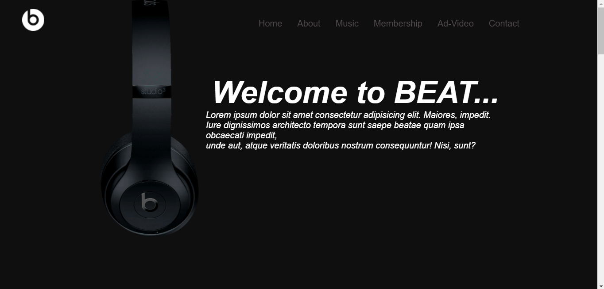

* **About Page:**

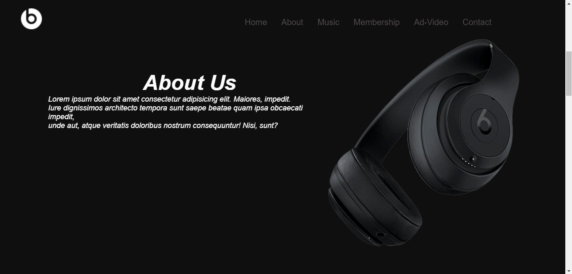

* **Music:**

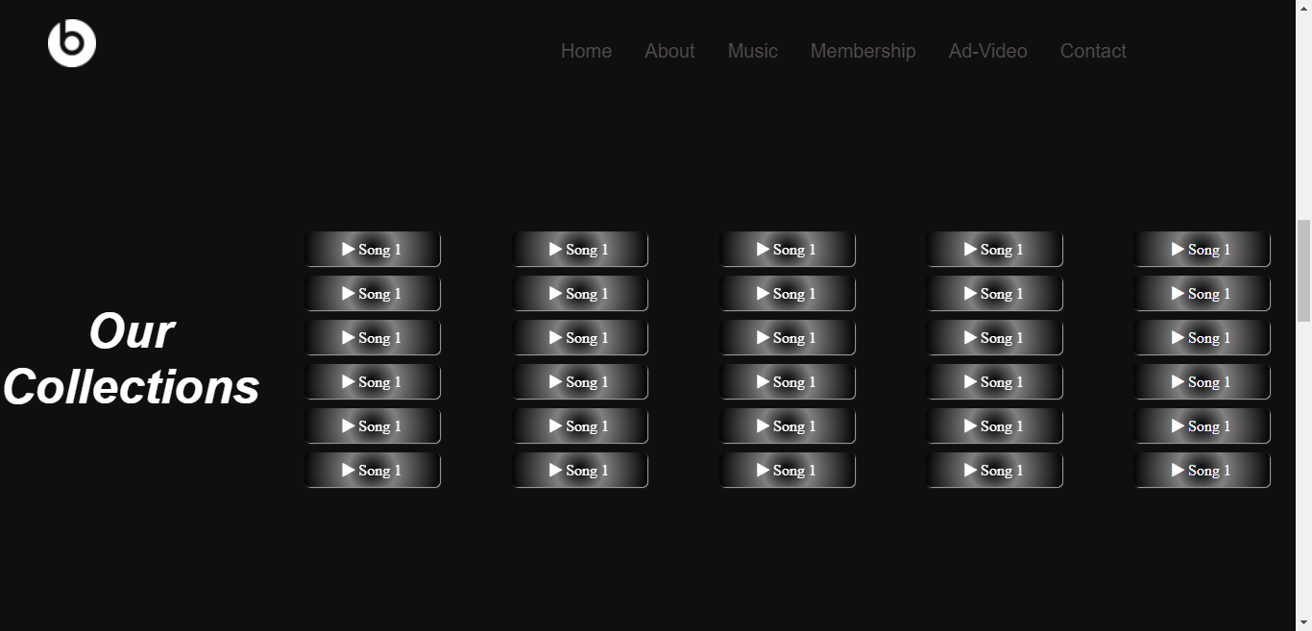

* **Membership**

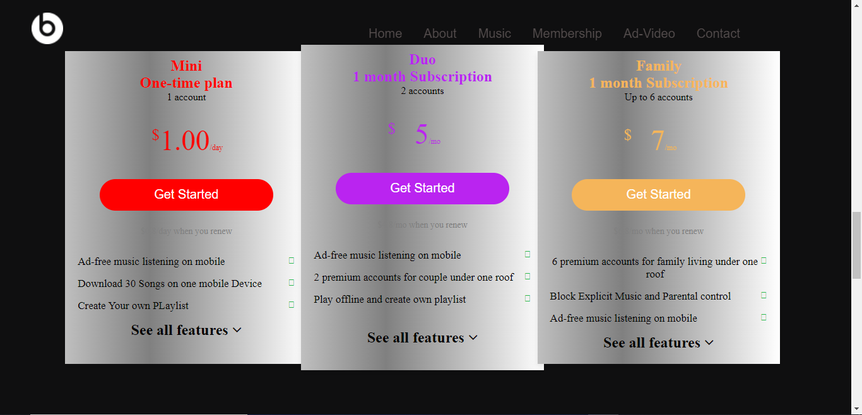

* **Ad-video:**

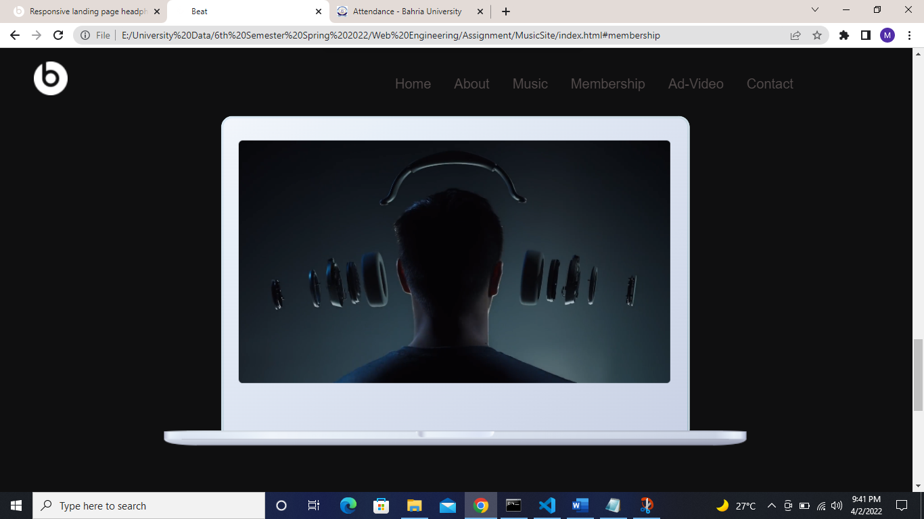

* **Contact:**

